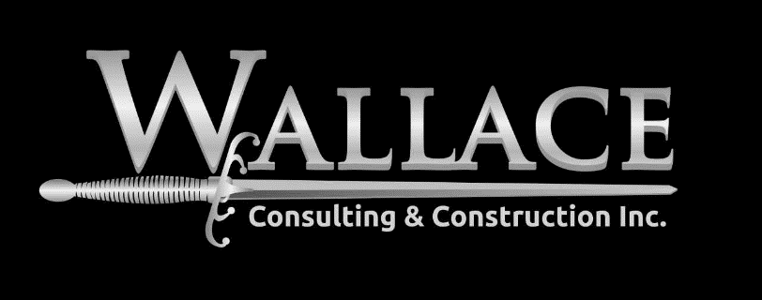

Lease Review and Substantiated Data for Negotiations

Information is power. For our clients we provide hard data and real costs to help explain the monetary result of specific lease terms. Everyone who signs a lease should know the implications of that lease, when one party can show those cost implications to the other party it makes negotiating fair terms for everyone a much easier conversation.

